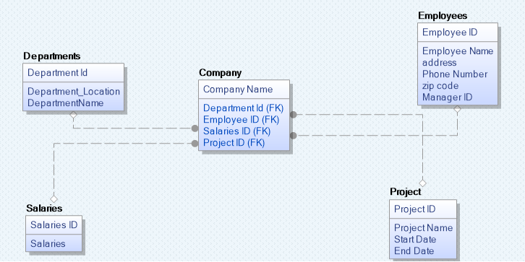

This is the example
In the above demonstration Company is a fact table having attributes departmentid, employeeID, salaries ID, Project ID which references to the dimension tables. Employee dimension table contains the attributes employee name, address, phone number, zip code, and managersD. Departments dimension table contains
attributes department location, departmentName and departmentID.Salaries dimension table contains the attributes such as salary ID and salaries. Project contains project ID, start date and end dates as attributes.
Each employee is assigned with project which will contain start date, end date. Each employee has also managers ID who he will be reporting to him. Each employee will also have salary which he will be receiving. Each employee will be working for different departments like R&D, finance, HR, Payroll and production.

Business processes and data regarding businesses are dispersed using fact tables and dimension tables in the star schema. Each dimension in the star schema is represented by a single-dimension table. With the use of a foreign key, the fact table and the dimension table are linked. The dimension tables are not connected to one another. Star schema is mainly used in data warehousing. It is mainly good for searching data when data is very large.

